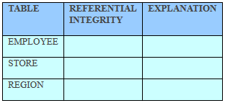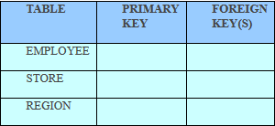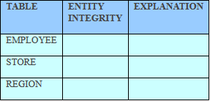

yes

yes

NA

Because the foreign keys have matching entry in the related table.

Because the foreign keys have matching entry in the related table.

None

REGION_CODE

EMP_TITLE

STORE_CODE

REGION_CODE

STORE_CODE

EMP_TITLE

Question 3.

Because the primary keys are unique and does not have null.

Because the primary keys are unique and does not have null.

Because the primary keys are unique and does not have null.

yes

yes

yes

Question 2.

Question 1.